Homework Assignment
Sections 6.5 & 6.6
Chris G. Waltzek
Clemson University

Homework Assignment Sections 6.5 & 6.6
Section 6.5
Complete the following problems from you textbook (an e-copy of the book is available on WebAssign). Due: your first class following fall break (e.g. Nov 5 or 6).

Section 6.5: 21, 22, 25, 26, 28, 29, 34
Q.21 The function f(w) is a probability density function (PDF) because it satisfies two key criteria:
1. $\int_{-∞}^{∞}{f\left(w\right)dw=1}.$
Verified via TI-84: $\int_{0}^{1}{f\left(w\right)dw=1}.$
2. f(w) ≥ 0 for each real number w, as verified in the TI-84 graphing function.

Q.22 The function h(x) is a probability density function (PDF) because it satisfies two key criteria:
1. $\int_{-∞}^{∞}{h\left(x\right)dx=1}.$ Verified via TI-84: $\int_{0}^{1}{h\left(x\right)dx=1}.$
2. h(x) ≥ 0 for each real number x, as verified in the TI-84 graphing function.

Q.25 No, the function h(y) is not a probability density function (PDF) because it fails to satisfy the two key criteria:
1. $\int_{-∞}^{∞}{h\left(y\right)dy≠1}.$ Verified via TI-84: $\lim_{N→∞}{\int_{0}^{N}{h\left(y\right)dy}}≈ .391$
2. h(y) ≠ 0 when y ≤ 0 for each real number y, as verified in the TI-84 graphing function.

Q.26 The function f(t) is not a probability density function (PDF) because it fails to satisfy the two key criteria:
1. $\int_{-∞}^{∞}{f\left(t\right)dt≠1}.$ Verified via TI-84: $\lim_{N→∞}{\int_{1.8}^{N}{f\left(t\right)dt}}≈ 5.26.$
2. f(t) ≠ 0 when t < 1.8 for each real number t, as verified in the TI-84 graphing function.

Q.28 The total number of hours (h) a student spends each day on Twitter, is distributed according to the density function T(h), for: 0 ≤ h ≤ 24; 0 elsewhere.
a. T is a PDF, because $\int_{-∞}^{∞}{T\left(h\right)dh=1}.$ Verified via TI-84:
$\int_{-∞}^{0}{T\left(h\right)dh=0; }\int_{0}^{24}{T\left(h\right)dh=1;} \int_{24}^{∞}{T\left(h\right)dh=0; }∴$ 0 + 1 + 0 = 1
b. The probability that the student will spend between 0.75 hours and 1.2 hours tomorrow on Twitter: $\int_{.75}^{1.2}{T\left(h\right)dh=26.8\%}$
c. A graph of T with the region whose area includes the answer to part a, is reviewed (see Figure 1.1).
Figure 1.1. PDF: T(h)
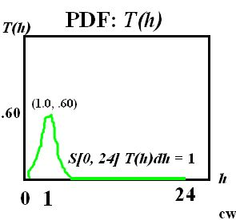
Note: The figure is from Calculus Concepts (2014), All Rights Reserved.

Q.29 The manufacturer of a new board game believes that the time it takes a child between the ages of 8 and 10 to learn the rules of this game has the probability density function g(t), when: 0 ≤ t ≤ 4; 0 elsewhere, where t = minutes.
a. The mean (µ) time it takes a child age 8 to 10 to learn the rules of this game: µ = $\int_{0}^{4}{g\left(t\right)dt= }2$ minutes.
b. Calculate the standard deviation (σ) of the learning times:
σ =$\sqrt{\int_{0}^{4}{(t-2)^{2}g\left(t\right)dt }}$= .894
c. P(t ≤ 3) = $\int_{0}^{3}{g\left(t\right)dt= }$.844; when 0 ≤ t ≤ 3. The probability that a child age 8 to 10 learns the rules of this game in less than three minutes is 84.4%.

Q.34 If g is a probability density function defined on -∞ ≤ x ≤ ∞, and a and b are real numbers such that a < b, the following statement is true:
$$P\left(x<a\right)+P\left(x>b\right)= 1-\int_{a}^{b}{g\left(x\right)dx }$$
The equation is true because the definition of a density function for a continuous or piecewise-continuous function a ≤ x ≤ b otherwise x = 0 implies: $P\left(x<a\right)+P\left(x>b\right)= 0.$ The definition of a density function for a continuous or piecewise-continuous function $\int_{-∞}^{∞}{f\left(x\right)dx=} 1;$ which implies:$1-\int_{a}^{b}{g\left(x\right)dx}=0$.
Therefore, it follows:
$$P\left(x<a\right)+P\left(x>b\right)= 1-\int_{a}^{b}{g\left(x\right)dx;}$$
$\left[0+0\right]=\left[1-1\right];$
$\left[0\right]=[0]$
Section 6.6: 2, 3, 5-7, 11, 13, 21, 26
Q.2 If x is a random variable with a uniform density function for 0 ≤ x ≤ 1, its cumulative distribution function F(x) = 0 for x < 0, is x for 0 ≤ x ≤ 1 and 1 for x > 1. Yes, all three statements are correct, because F(x) remains at 1 when x > 1; the right end behavior of any cumulative distribution function is 1, representing certain events. The left end behavior of any cumulative distribution function is zero representing impossible events. Cumulative distribution functions always increase.
Q.3 False, the value of k that makes G(t) an exponential density function is k = 1.
Q.5 The graph of G(t) is a possible accumulation density function because due to its non-decreasing nature.
Q.6 The graph of C(m) is not an accumulation density function because it is decreasing where 0 ≤ m < 5.
Q.7 The graph of S(x) is not a cumulative density function because S(x) ≠ 0, when x < 0. Verbally: left end behavior appears to approach, yet not reach, zero.
Q.11 At a certain grocery checkout counter, the average waiting time is 2.5 minutes. Suppose the waiting times follow an exponential density function.
a. The equation for the exponential distribution of waiting times follows (µ = 2.5; k = 1 / 2.5 = .4):
f(x) = $ke^{-kx} for x ≥0$; f(x) = $.4e^{-.4x} for x ≥0.$
The mean of an exponential distribution is 1/k. A graph of the equation and location of the mean waiting time is illustrated (see Figure 1.2).
Figure 1.2 Graph of Equation & Mean Waiting Time
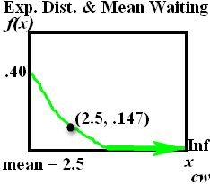
Note: The Figure is from Calculus Concepts (2014), All Rights Reserved.

b. What is the likelihood that a customer waits less than 2 minutes to check out?
$P\left(x<2\right)=\int_{0}^{2}{.4e^{-.4x}dx= 55\% }$Greater than even odds.
c. What is the probability of waiting between 2 and 4 minutes? $P\left(2<x<4\right)=\int_{2}^{4}{.4e^{-.4x}dx= 24.7\% }$
d. What is the probability of waiting more than 5 minutes to check out?
$$P\left(x>5\right)= \int_{5}^{∞}{.4e^{-.4x}dx= }\lim_{N→∞}{\int_{5}^{N}{.4e^{-.4x}dx}}=$$
$\lim_{N→∞}{[.4e^{-.4N}/-.4 }–(.4e^{-.4(5)})/-.4]$ =
$\lim_{N→∞}{[-e^{-.4N} }–\left(-e^{-.4\left(5\right)}\right)]$ =
$0 –\left(-.135\right)≈13.5\%$

Q.13 Luggage Weight - Suppose the weight of pieces of passenger luggage for domestic airline flights follows a normal distribution, where µ = $40 pounds;$σ = 10.63 pounds.
a. Calculate the probability that a piece of luggage weighs less than 45 pounds. $P\left(w<45\right)= \int_{0}^{45}{(1/(10.63\sqrt{2π})e^{-(w-45)^{2}/(2(10.63)^{2})}) dw= }$68.1%
b. Calculate the probability that the total weight of the luggage for 80 passengers on a particular flight is between 1200 and 2400 pounds (Assume each passenger has one piece of luggage).
$P\left(15 <w<30\right)= \int_{15}^{30}{(1/(10.63\sqrt{2π})e^{-(w-40)^{2}/(2(10.63)^{2})}) dw= }$16.4%
c. Calculate where the probability density function for the weight of passenger luggage is decreasing most rapidly. Next, f ’(w) has a minimum at w = 50.63 pounds therefore f(w) has an inflection point at w = 50.63 pounds which is the weight of passenger luggage that decreases most rapidly.
Q.21 The cumulative distribution function F follows (see Figure 1.3).
Figure 1.3. Cumulative Distribution Function F
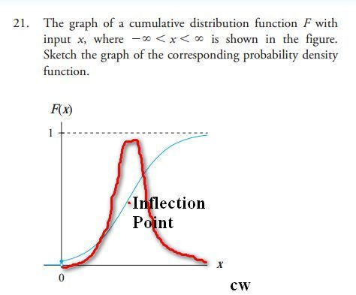
Note: The Figure is from Calculus Concepts (2014), All Rights Reserved.

Q.26 Given the following density function, the three questions follow:
$$g\left(x\right)=\left\{\begin{aligned}.25, when 5≤x≥9; \\ 0, when &x<5 or x>9, \end{aligned}\right.$$
a. The corresponding cumulative density function (G) is identified via the anti-derivative of .25 (.25x):
$$G\left(x\right)=\left\{\begin{aligned}0, when &x<5; \\ .25x, when &5≤ x≤9; \\ 1, when &x>9.\end{aligned}\right.$$
b. Both g and G identify the probability that x < 6.08:
g: $\int_{5}^{6.08}{g\left(x\right)dx= }27\%$
G: G(6.08) – G(5) = .25(6.08) – .25(5) = 1.52 – 1.25 = 27%
c. The graphs of g and G follow, respectively (see Figures 1.4 & 1.5).
Figure 1.4. Graph of g
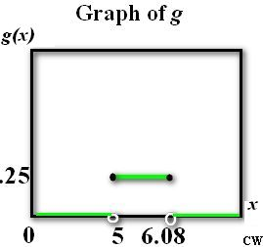
Note: The Figure is based on a question from Calculus Concepts (2014), All Rights Reserved.

Figure 1.5. Graph of G
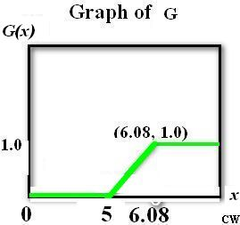
Note: The Figure is based on a question from Calculus Concepts (2014), All Rights Reserved.

